**Cloud Application Development**

**Image Recognition with IBM Cloud Visual Recognition**

**Phase-5**

**Outline the project’s objective, design thinking process and development phases.**

**Project Objective:**

The project involves creating an image recognition system using IBM Cloud Visual Recognition. The goal is to develop a platform where users can upload images, and the system accurately classifies and describes the image contents. This will enable users to craft engaging visual stories with the help of AI-generated captivating visuals and compelling narratives.

In today's digital age, businesses and organizations face the challenge of efficiently categorizing and extracting valuable insights from vast amounts of visual data, including images and videos. Traditional manual methods for image analysis are time-consuming, error-prone, and not scalable. To address this problem, we aim to leverage IBM Cloud Visual Recognition to develop an automated and accurate image classification and analysis system. This system will enable us to identify objects, detect anomalies, and gain valuable insights from visual data, ultimately improving decision-making processes and operational efficiency."

**Design Thinking:**

**1.Set Up an IBM Cloud Account:**

If you don't already have one, create an IBM Cloud account and log in.

**2.Create an Instance of Visual Recognition Service:**

In your IBM Cloud dashboard, create an instance of the Visual Recognition service.

**3.Get API Credentials:**

Once your service instance is created, you'll receive API credentials (an API key and URL) that you will use to authenticate your requests.

**4.Collect and Prepare Images:**

Gather the images you want to analyze. Make sure they are in a suitable format (e.g., JPEG, PNG) and meet any size or quality requirements.

**5. Train a Custom Model:**

If you need to recognize specific objects or classes, you can train a custom model using your image dataset. This step is optional but can improve recognition accuracy for specific use cases.

**6. Use the API:**

Depending on your needs, you can use the API for various purposes:

* Classify Images: Submit images to the API for classification. The API will return labels or tags describing the objects or scenes in the image.
* Detect Faces: You can also use the API to detect faces in images, along with attributes like age, gender, and emotion.
* Train and Re-Train Models: If you're using custom models, you may need to periodically re-train them with new data to improve accuracy.

**7. Handle API Responses:**

Parse the API responses to extract the information you need for your application.

**8. Integrate with Your Application:**

Incorporate the image recognition capabilities into your application or service using the API credentials and the appropriate API endpoints.

**9. Test and Iterate:**

Test your integration thoroughly and fine-tune your application as needed to achieve the desired recognition accuracy and performance.

**10. Monitor and Maintain:**

Regularly monitor the performance of your image recognition system. If you're using a custom model, consider re-training it periodically to adapt to changing data and improve accuracy.

**11. Manage Costs:**

Be mindful of the pricing structure for IBM Cloud Vision Recognition, as usage can incur costs based on the number of API calls and features used.

**Description of user interface, technical implementation details, and integration of IBM Cloud Visual Recognition**

IBM Cloud Visual Recognition is a cloud-based service that leverages machine learning and image recognition capabilities to analyze and classify visual content within images and videos. It can be integrated into various applications, and it provides a user-friendly interface for both developers and business users. Here's an overview of the user interface, technical implementation details, and integration of IBM Cloud Visual Recognition:

**User Interface:**

The IBM Cloud Visual Recognition service typically offers a web-based user interface that allows users to manage and configure the service. The user interface includes the following components:

**Dashboard:**

This is where users can set up and manage their Visual Recognition instances. Users can create, delete, and configure instances for their specific needs.

**Models:**

Users can create, train, and manage custom machine learning models. They can upload images, define classes, and train the model to recognize specific objects or concepts within the images.

**Analyze:**

This is where users can analyze images and videos by submitting them to the service for classification, object detection, and other tasks. Users can also review the results and perform custom tagging or labeling.

**Usage and Billing:**

Users can view their usage statistics and billing information, helping them keep track of their service consumption.

**Technical Implementation Details:**

Integrating IBM Cloud Visual Recognition into an application involves several technical details:

**APIs:**

Visual Recognition provides RESTful APIs that allow developers to interact with the service programmatically. These APIs can be used to classify images, create and manage custom models, and fetch results.

**SDKs:**

IBM offers software development kits (SDKs) for various programming languages, making it easier for developers to integrate Visual Recognition into their applications. These SDKs provide convenient methods for interacting with the service.

**Custom Models:**

To create custom models, developers need to upload training data (images) and label them accordingly. The service uses this data to train the model to recognize specific visual content.

**Security:**

API keys and access control mechanisms ensure the security of interactions with the service, allowing only authorized users to access and use Visual Recognition.

**Integration:**

Integrating IBM Cloud Visual Recognition into an application involves the following steps:

**Create an Instance:**

Users need to create an instance of IBM Cloud Visual Recognition on the IBM Cloud platform. This instance will be associated with their project and provide access to the service.

**Training:**

For custom models, users need to upload training data and label it. Visual Recognition will use this data to train a model tailored to the user's needs.

**API Integration:**

Developers can integrate the service into their applications using the provided APIs or SDKs. This allows their applications to send images or videos for analysis and receive classification results.

**Scalability:**

IBM Cloud Visual Recognition is scalable and can handle a wide range of workloads, making it suitable for applications with varying usage patterns.

**Monitoring and Maintenance:**

Users can monitor the performance of their custom models and retrain them as needed to improve accuracy.

IBM Cloud Visual Recognition provides a user-friendly interface for managing the service, along with APIs and SDKs for technical implementation in applications. Custom models can be created and trained, making it a versatile tool for a wide range of applications involving image and video analysis.

**Explain how AI-generated captions enhance user engagement and storytelling.**

AI-generated captions can significantly enhance user engagement and storytelling in various contexts. These captions are generated using advanced natural language processing techniques, and when used effectively, they can provide several benefits:

**Accessibility:**

AI-generated captions make content more accessible to a broader audience, including individuals with hearing impairments. This inclusivity promotes a more diverse and engaged user base.

**Improved SEO:**

Search engines can index and rank content with captions more effectively. This can increase the visibility of your content and attract more users, leading to higher engagement.

**Better Content Comprehension:**

Captions provide additional context and clarity to visual content such as images, videos, or infographics. This helps users understand the content better, which can lead to longer engagement and a reduced bounce rate.

**Multilingual Support:**

AI can generate captions in multiple languages, making your content accessible to global audiences. This not only broadens your reach but also engages users from different linguistic backgrounds.

**Personalization:**

AI can analyze user preferences and behaviors to generate captions tailored to individual tastes and interests. Personalized captions can enhance engagement by delivering more relevant content to users.

**Time-saving:**

For users, AI-generated captions save time and effort. They don't have to manually transcribe or interpret content, allowing them to focus on the core message or storyline.

**Consistency:**

AI ensures that captions are consistently generated, reducing the chances of human error or inconsistency in content interpretation. This consistency can contribute to a more cohesive and engaging storytelling experience

**Real-time Interaction:**

In live or real-time content, AI-generated captions can provide immediate context, allowing users to stay engaged and informed even when they can't hear or understand the spoken content.

**Storytelling Enhancements:**

In the context of storytelling, AI-generated captions can offer creative opportunities by adding descriptive or emotive elements to the narrative. These captions can complement the storyline by providing additional layers of information, emotions, or context.

**Data-Driven Insights:**

AI can analyze user interactions with content and captions to provide valuable insights into what engages users the most. This data can help content creators refine their storytelling techniques and improve user engagement.

**Content Distribution:**

AI-generated captions can be used to create more shareable content. When users share content with captions, it can spread more easily across social media platforms, reaching a wider audience.

**Enhanced User Experience:**

Engaging and well-crafted AI-generated captions can make the overall user experience more enjoyable. This, in turn, can lead to increased user satisfaction and loyalty.

AI-generated captions can significantly enhance user engagement and storytelling by making content more accessible, improving content comprehension, and offering personalization. They also provide valuable insights for content creators, ultimately leading to a more enjoyable and effective storytelling experience for both creators and consumers.

**IBM account**



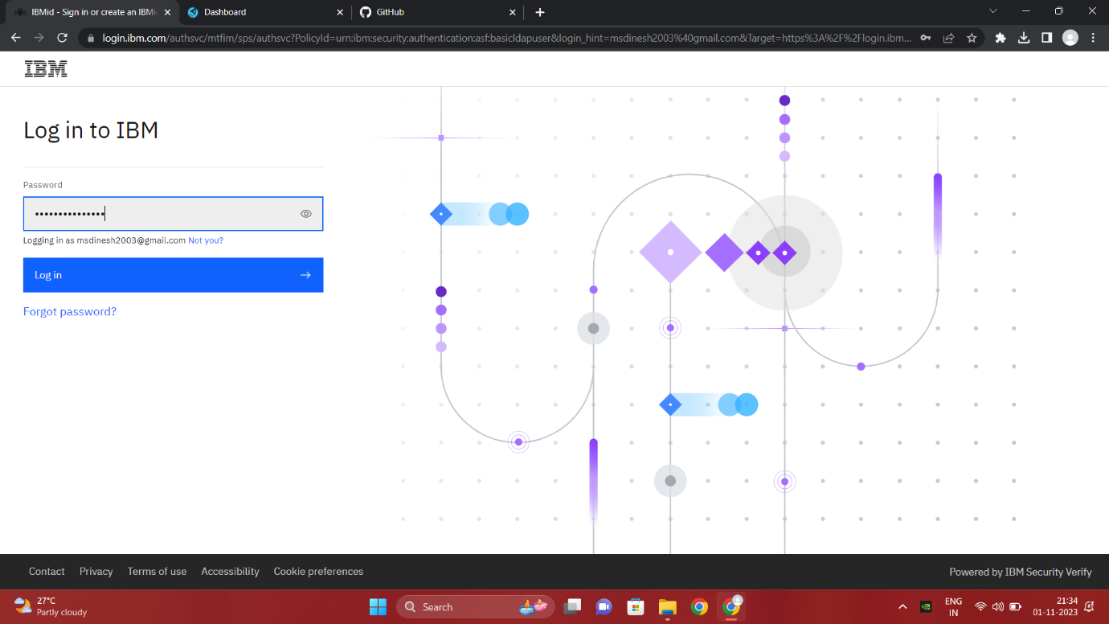

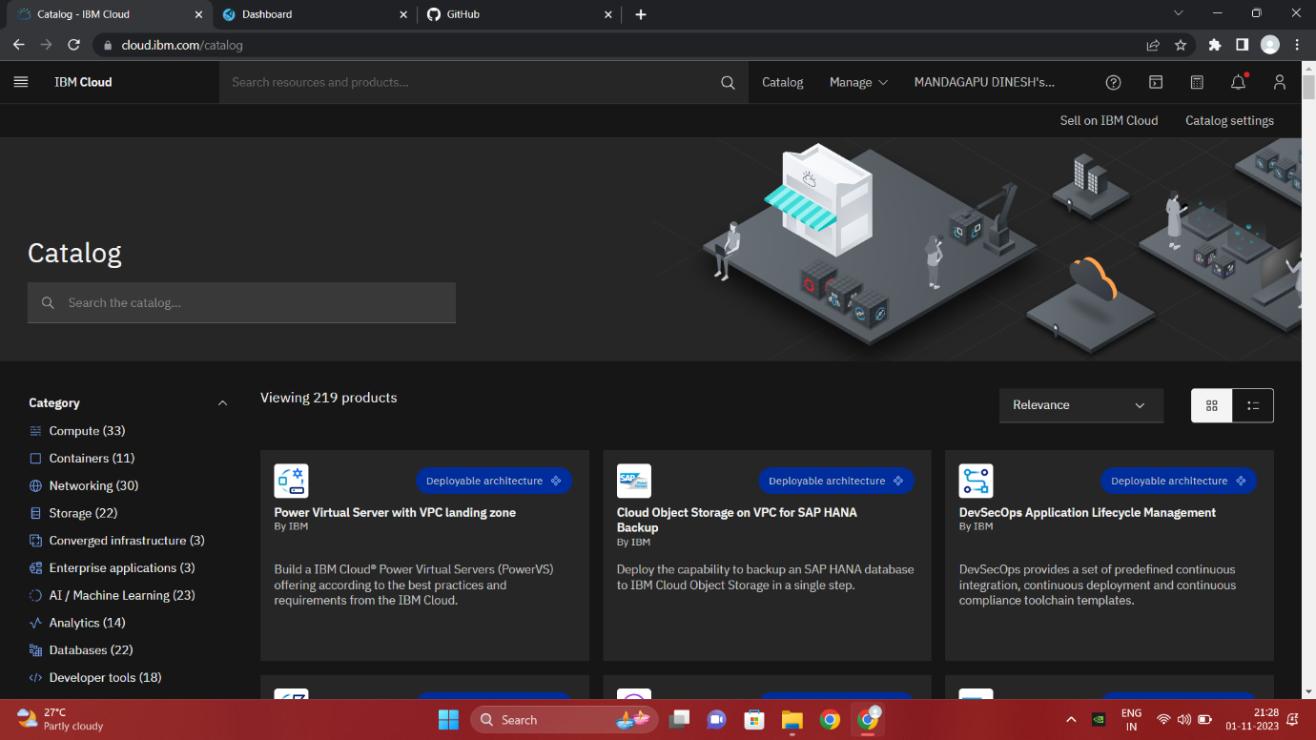

**Image Recognition**

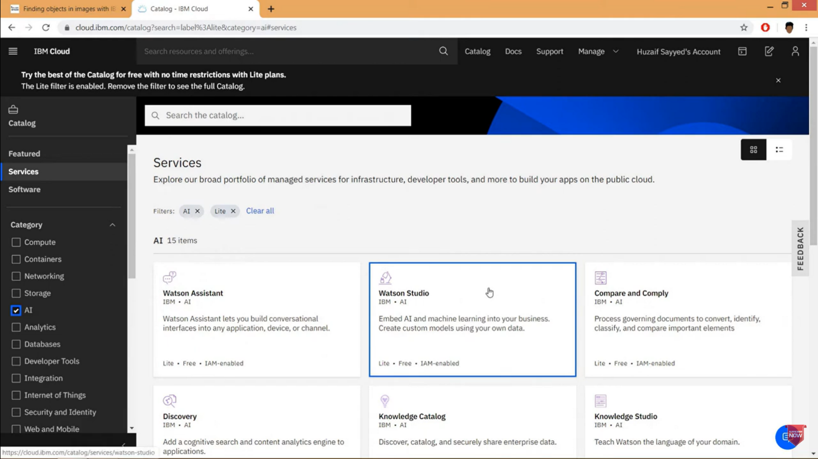

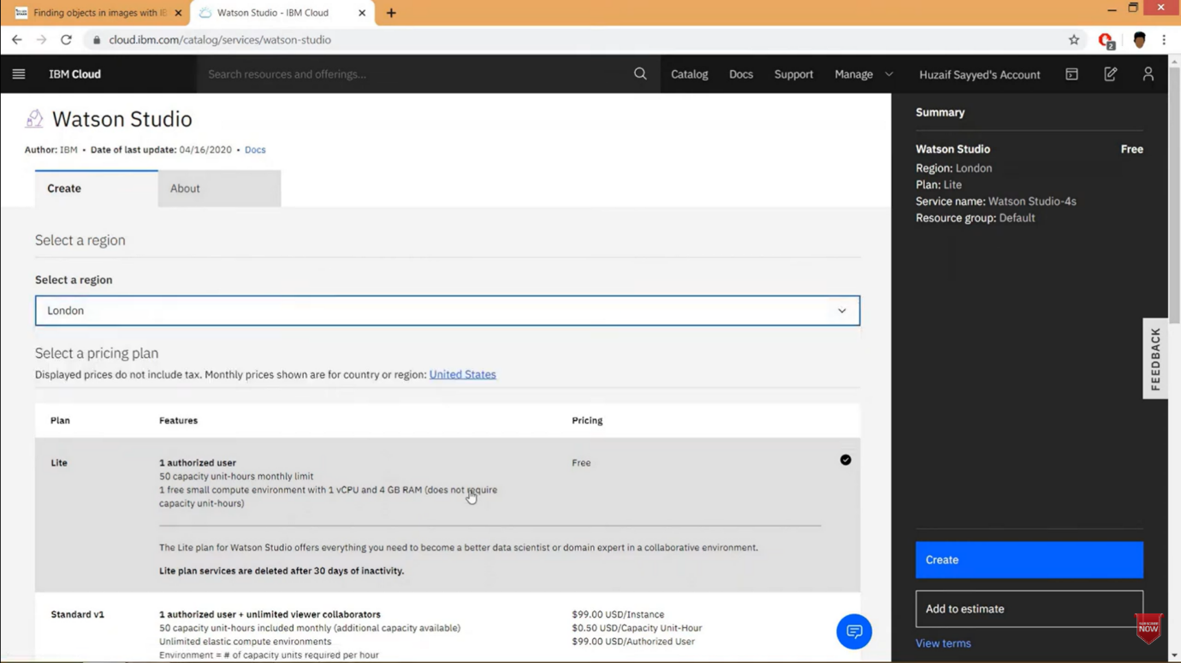

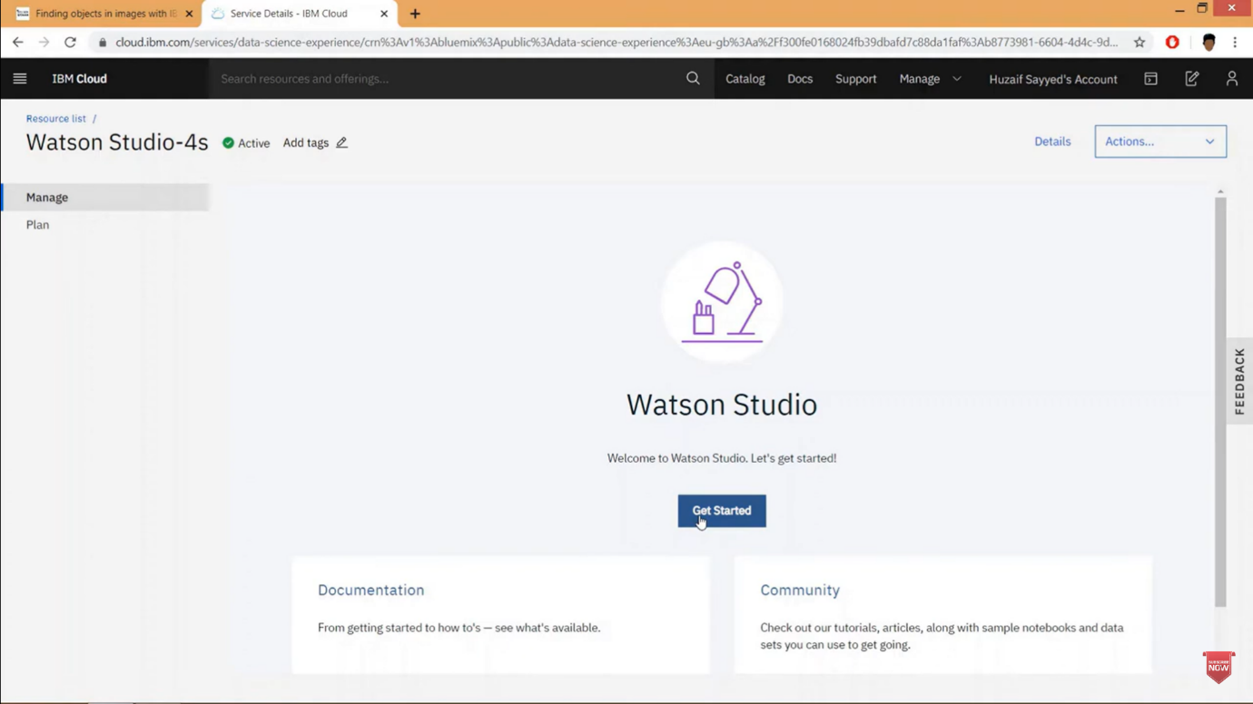

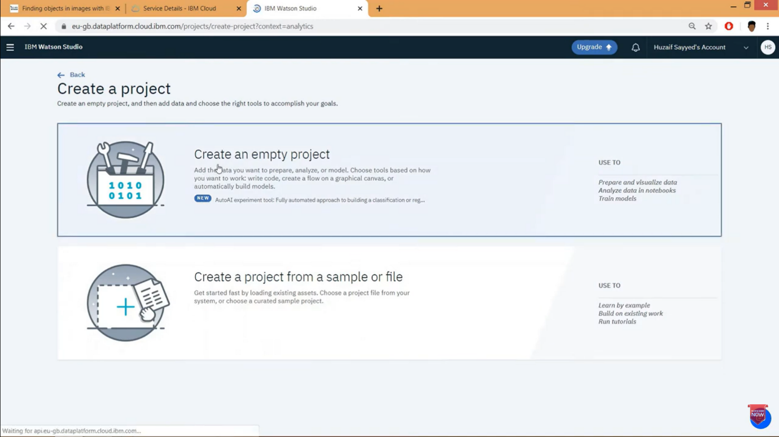



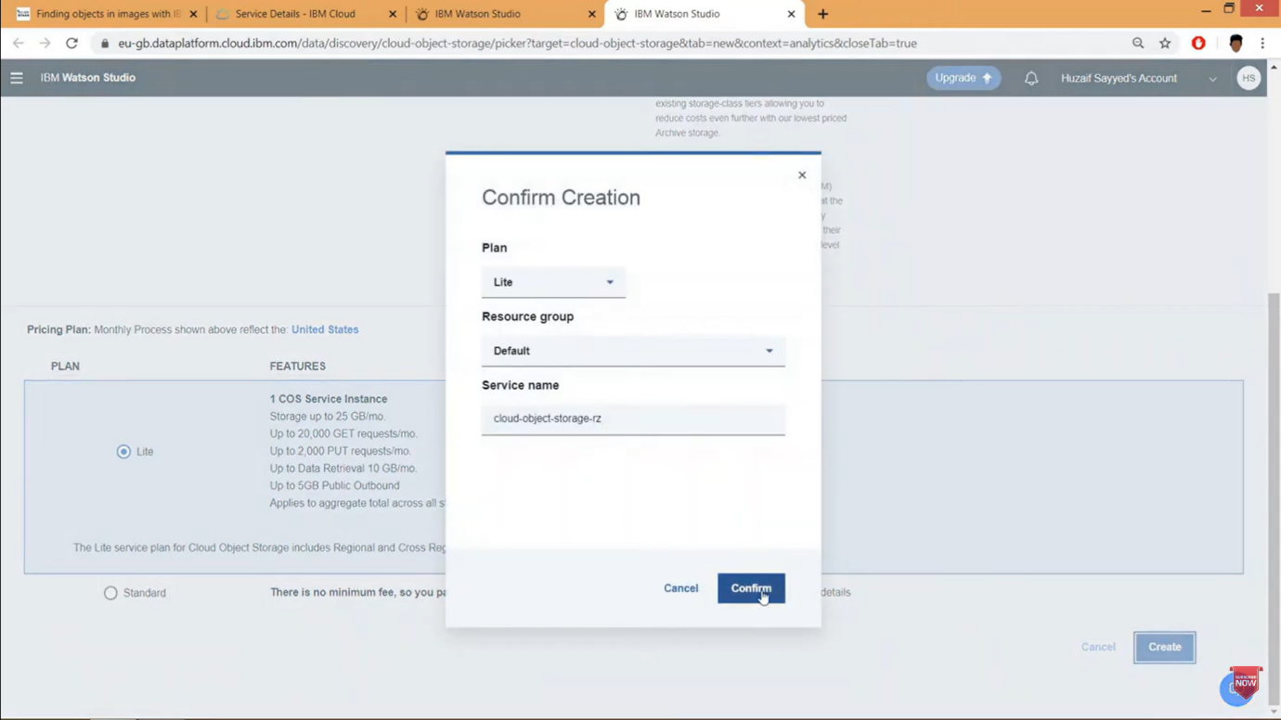

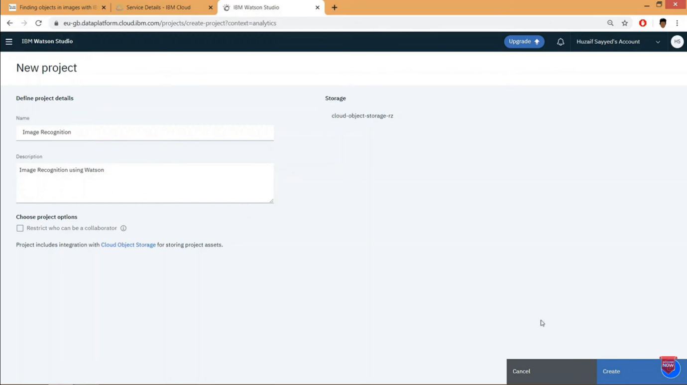



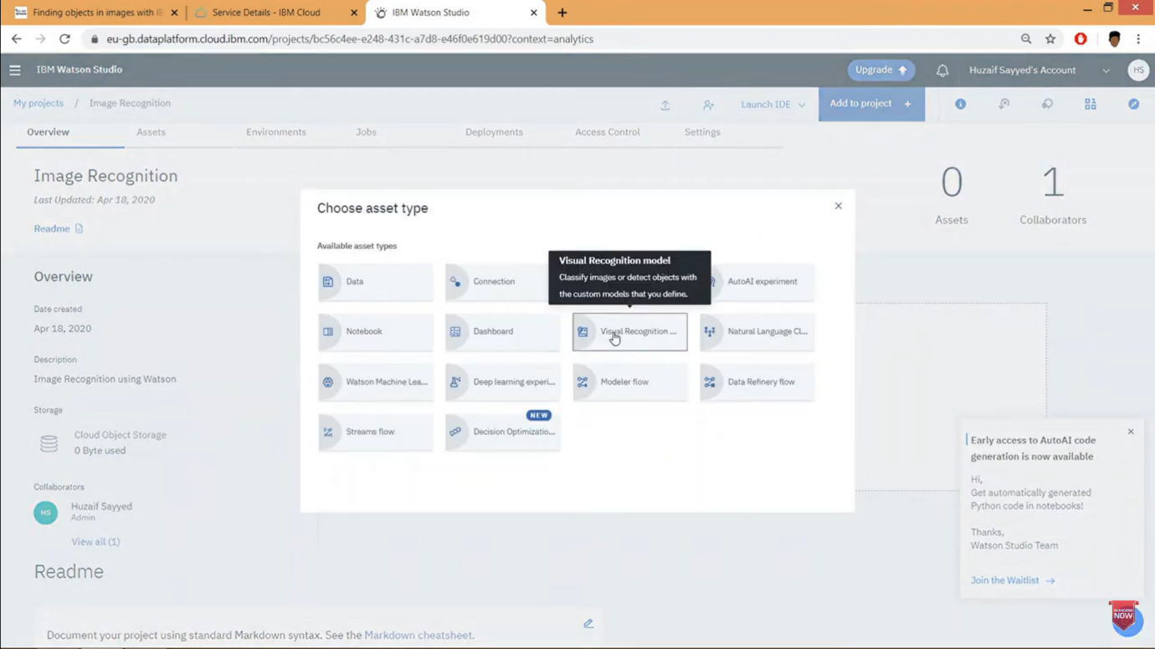

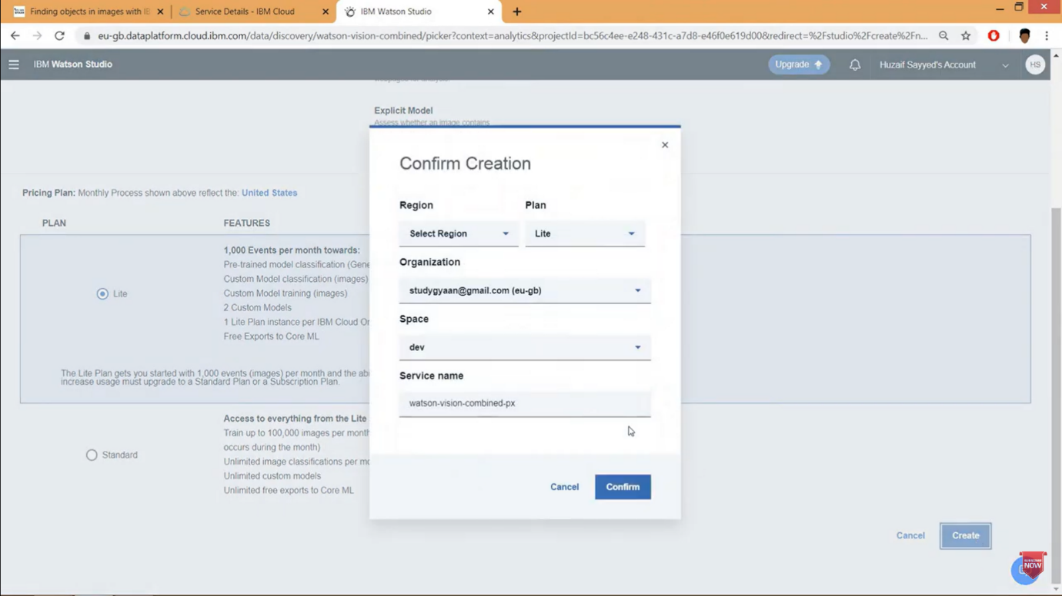



**TESTING**

